Piano Recital:

Robert Schmidli
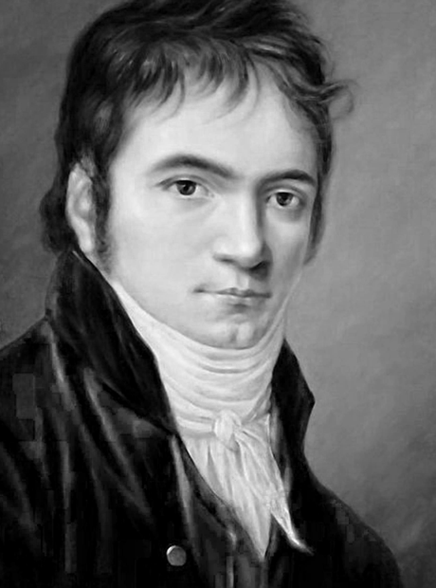

6 April 2024
27 Custance Street, Farrer 2607

Program

Johann Sebastian Bach (1685 – 1750)
Toccata in D major BWV 912 (?1710)

Ludwig van Beethoven (1770 – 1827)
Sonata no 4 in E flat major Op 7 “Grand Sonata” (1796)

- Allegro molto e con brio
- Largo, con gran espressione
- Allegro – trio
- Rondo: Poco allegretto e grazioso

Frédéric Chopin (1810 – 1849)
Scherzo no 1 Op 20 in B minor (1835)

