Dr Robert Schmidli
ANUMS
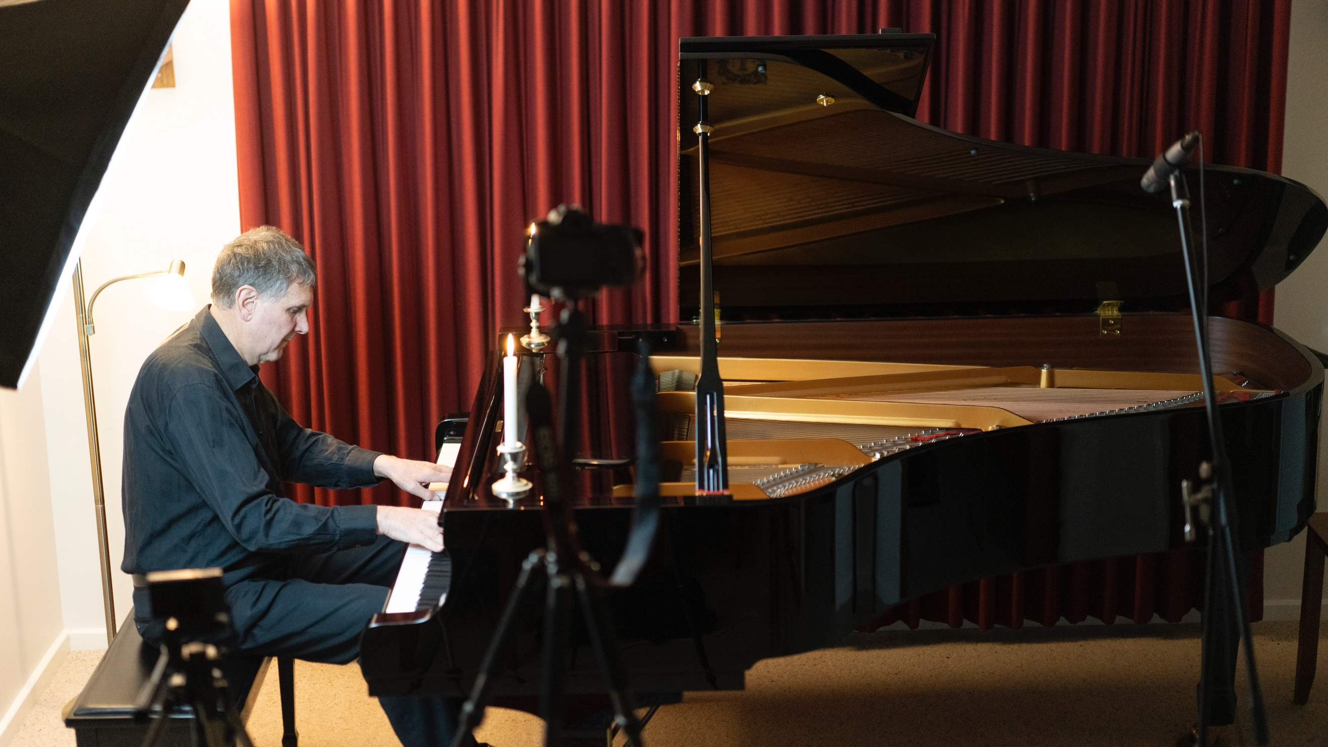

Dr Robert Schmidli meets me at his front door and ushers me into his living room. Only…it doesn’t look like a living room right now. It looks more like a recording studio.

In one corner sits a sparkling grand piano. Placed around it are microphones, lights and numerous cameras on tripods.

Dr Schmidli, who is an endocrinologist at the ANU Medical School, is a classical pianist in his spare time.

“I do about a dozen public concerts a year,” he tells me.

While some concerts are held here in his home, others are with his piano club, or for charities or at the Wesley Music Centre.

“My opportunities to perform were curtailed when the lockdown laws were introduced,” he says.
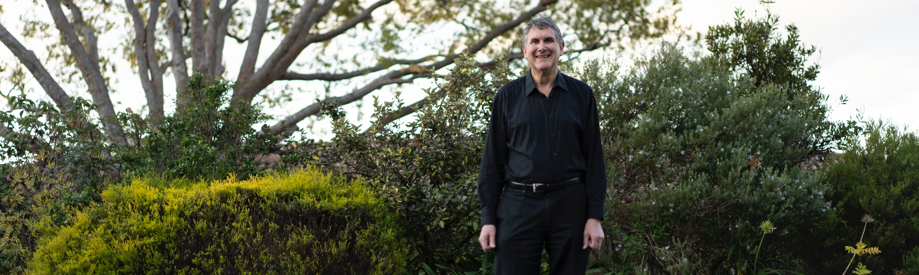

In spite of the restrictions, he wanted to keep performing for his friends. That’s when he thought about recording himself.

“I had the gear and I thought, ‘Well, I've got to practice for something. Otherwise, I'll just let it go.’”

Dr Schmidli created a YouTube channel and started uploading his videos. He distributes his videos on his social media channels and by email.

I ask Dr Schmidli if he has any favourites.

“Absolutely, yes. Beethoven. But I've got others as well. I'm doing a lot of Chopin for these because he's written a lot of short pieces. They are very popular and go down well with my audiences.”

To join Dr Schmidli’s audience, you can find his videos here.

