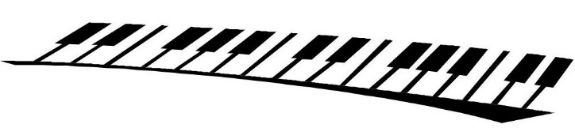
Klavier Music Association
Presents
Michaella Edelstein (Soprano)
Robert Schmidli (Piano)

Schubert: Nacht und Traume
Schumann: Widmung
Richard Strauss: Zueignung

Sunday 22 November at 3pm
All Saints Church
9-15 Cowper St
Ainslie ACT 2602
Entry: $5 donation
RSVP robert@schmidli.com.au
COVID-19 social distancing guidelines will apply

