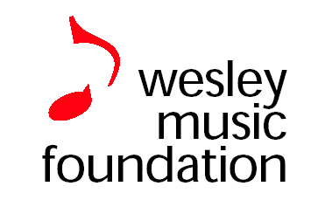**Wednesday**

**Lunchtime**

**Concerts**

**Robert Schmidli**

**Piano**

**Three Scarlatti Sonatas**

**Beethoven: Sonata no 32 Op 111 in C minor**

**Khatchaturian: Toccata**

**18th July 2018**

**12.40 – 1.20 pm**

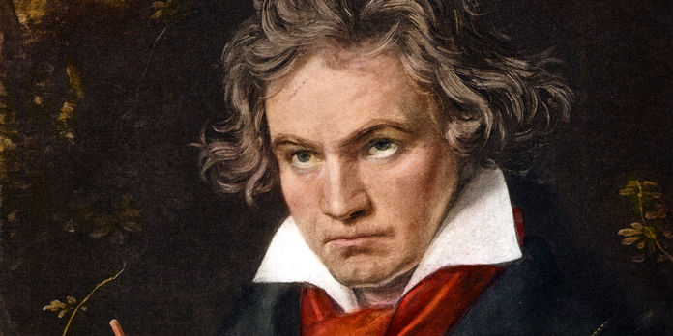

*Entry $10 or donation. Includes program & refreshments*

*Wesley Music Centre*

*20 National Circuit, Forrest wesleymc@music.wesleycanberra.org.au*

*6232 7248*