CLINICOPATHOLOGICAL SESSION 5

“Too little salt or too much water”

Overall aim: To introduce an approach to the investigation, diagnosis and management of patients presenting with the problem hyponatraemia

Specific learning objectives:
At the completion of this session you should be able to:

1. Described the neuro-hormonal-renal mechanisms involved in the regulation of body sodium and water homeostasis

2. Describe the clinical features and potential consequences of hyponatraemia

2. Understand what is meant by hypertonic hyponatraemia, pseudo-hyponatraemia, or hypotonic hyponatraemia

3. Classify the different causes of hypotonic hyponatraemia according to (i) urinary osmolarity, (ii) whole body fluid status, and (iii) urine sodium concentration

4. List the common causes of the Syndrome of Inappropriate Antidiuretic Hormone (SIADH)

5. Understand which endocrine conditions can contribute to hyponatraemia

6. Discuss the initial management of hyponatraemia according to its severity and whether its onset has been acute or chronic

7. Discuss the on-going management of hyponatraemia according to its cause

8. Understand the investigation, differential diagnosis and management of pituitary insufficiency

Instructions:

- Pre-reading
review of previous lectures/practicals and PBLs related to fluid and electrolyte balance

- Prepare answers for questions 1-4 in the clinical scenario prior to the tutorial

- The topic will be introduced with a clinical history

- You will be shown laminated pathology reports and radiological images

Clinical History:

Ferdinand Tobruk is a 34-year-old fund manager was referred into the emergency department by his general practitioner because of abnormal blood test results. He had gone to see his GP earlier that day due to symptoms of increasing lethargy, confusion, nausea and intermittent frontal region headaches over a three-week period. His concerned girlfriend had encouraged him to seek medical assistance, as he was feeling so awful, and at times even seemed confused.

The Urea/Electrolytes/Creatinine (UEC) blood test result was the one concerning his GP.

Na 117 mmol/l [135-145]
K 3.7 mmol/l [3.5-5.2]
Cl 87 mmol/l [95-110]
Urea 3.1 mmol/l [2.5-7.5]
Cr 55 µmol/l [60-110]
Bicarbonate 17 mmol/l [22-32]
Glucose 3.5 mmol/l [3.5-5.5 fasting]

1. Please comment on the pertinent findings in Ferdinand’s UEC blood test result. Also calculate his serum osmolarity from these results.

- Ferdinand’s serum UEC show very marked hyponatraemia with accompanying low chloride, creatinine, bicarbonate and borderline low glucose
- The calculated osmolarity is 248 mOsm/L (normal range 275-295 mosm/L) which is abnormally low
Most common used formula for calculation serum osmolarity

Calculated osmolarity = 2 x ( [Na⁺] + [K⁺] ) + [Glucose] + [Urea] (all in mmol/L)

2. Describe the clinical features and potential consequences of acute and chronic hyponatraemia. What factors contribute to the severity of the symptoms?

- Symptoms of hyponatraemia

Severity | Symptoms
Absent or Mild
Moderate | Nausea  Confusion  Headache
Severe | Vomiting  Seizures  Coma (Glasgow coma score <8)

- Factors that contribute to the severity of symptoms
  - Rate of onset of hyponatraemia
    - Acute (within 48 h) – more severe symptoms
    - Chronic (>48 h) – less severe symptoms, or in which there is no clear evidence of onset
  - Severity of hyponatraemia (NB severity should be primarily assessed clinically)
    - Mild: serum sodium130-135 mmol/L
    - Moderate: serum sodium 125-129 mmol/L
    - Severe: serum sodium 115-124 mmol/L
    - Profound: serum sodium <115 mmol/L
  - Capacity to adapt
    - Baseline cognitive function
    - Age, if <16 years, limited intracranial volume limiting brain expansion
    - Co-morbidities (e.g. sepsis, hypoxaemia, acute liver or renal failure)

Notes:
With acute onset of hyponatraemia, due to oncotic pressures, water enters cells, can result in neuronal (brain) swelling.
For this reason, more rapid correction of acute onset hyponatraemia is advisable (stops water entering cells and brain swelling).

With chronic onset of hyponatraemia cells are able to adapt to reduce the risk of swelling, by an efflux is intracellular osmolytes (inorganic and organic (e.g. creatinine and glutamate)- reduces intracellular oncotic pressure.
For this reason, rapid correction of chronic hyponatraemia can be dangerous due to rapid intracellular to extracellular water shifts, which can cause osmotic demyelination.

Osmotic demyelination
The speed of correction of hyponatraemia should be slow (no more than 10 mmmol/L per 24 hour, less in high-risk patient), in patients with chronic hyponatraemia. Patients are at risk of osmotic demyelination syndromes, most commonly in the pons (Central Pontine Myelinolysis, CPM). CPM is a catastrophic condition that may result in permanent quadriparesis, locked-in-syndrome, cranial nerve deficits or loss of consciousness and death.

3. What are the various causes of hyponatraemia and how are they classified?

- Step one – is it hypertonic hypotnatraemia, pseudohyponatraemia or hypotonic hyponatraemia?

  - Serum measured osmolality is useful in differentiating
  - Hypertonic hyponatraemia (measured serum osmolality is >295 mOsm/kg)
    - Occurs when there is a substance in blood at high concentration that results in intracellular water shifts to the extracellular space (e.g. hyperglycaemic states).
  - Pseudohyponatraemia (calculated serum osmolarity is low, but laboratory measured osmolality is normal = 275-295 mOsm/kg)
    - Occurs as a consequence of an abnormal increase in proteins or lipids in blood, such as occurs in multiple myeloma and severe hypertriglyceridaemias. This reduces aqueous component of serum – which affects usual measurement of electrolytes in laboratory (makes them seem lower)- but does not alter laboratory measured osmolality.
  - Hypotonic hyponatraemia (calculated serum osmolarity and measured osmolality <275 mOsm/L (mOsm/kg)) (go to step 2 and see Figure 3)

- Step 2 – For hypotonic hyponatraemia – is the urinary osmolality < or > 100 mOsm/L (See Figure 3)

  - Urine osmolality < 100 mOsm/kg
    - Pyschogenic polydipsia
    - Chronic low solute diets
      - “Tea and toast diets”
      - Anorexia
      - “Potomania” – beer diet

  - Urine osmolality > 100 mOsm/kg (go to step 3)

- Step 3 – For hypotonic hyponatraemia with urine osmolality > 100 mOsm/kg (see Figure 3)

  - Causes can be differentiated by knowing-
    - Whole body fluid status (reduced, normal, increased)
    - Urinary sodium concentration (<30 mmol/L or >30 mmol/L)

  - Reduced whole body fluid
    - Urinary sodium is < 30 mmol/L (suggests extra-renal loss of Na⁺)
      - Vomiting
      - Diarrhoea
      - Burns
      - “Third space” losses – sepsis, cardiogenic shock, pancreatitis

    - Urinary sodium is >30 mmol/L (suggests renal loss)
      - Mineralocorticoid deficiency
      - Diuretics
      - Salt wasting nephropathy
      - Cerebral salt wasting (controversial diagnosis)

  - Normal whole body fluid
    - Urinary sodium is >30 mmol/L
      - SIADH (see list of causes)
      - Hypocortisolaemia
      - Hypothyroidism

  - Increased whole body fluid
    - Urinary sodium is < 30 mmol/L
      - Liver disease
      - Heart failure
      - Nephrotic syndrome

    - Urinary sodium is >30 mmol/L (suggests renal loss)
      - Renal insufficiency (fluid retention, but renal Na+ loss)

Figure 1: Evaluation of hypotonic hyponatraemia
(Ref: Buffington M.A. and Abreo K. Journal of Intensive Care Medicine 2016, 31:223-236)
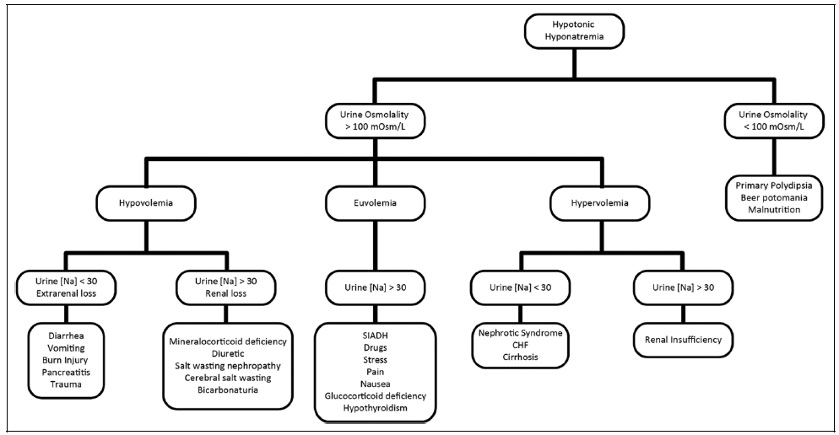

4. How often is hyponatraemia multifactorial in origin?

- Very common- examples:
  - IV dextrose- post-operatively, at which time ADH is also high due to pain
  - Diuretics, ACE inhibitors and SSRI’s in a patient with pneumonia
  - Extreme exercise- increases ADH + salt loss in sweat + high water consumption

5. What questions would you ask Ferdinand when you take his medical history and why?

- Presenting complaint:
  - Headaches and confusion warrant extensive neurologic history, including red flags of headaches, and visual/neurologic deficits, symptoms of high intracranial pressure. Given his confusion, assistance with the history by asking his next of kin may be necessary.

  - Nausea has diverse causes including gastrointestinal, central, toxic/drug, metabolic/endocrine, infectious and psychogenic causes.

  - Given his hyponatraemia, some assessment/quantification of volume status (oedema, thirst, water and salt intake), and fluid losses is necessary (vomiting, diarrhoea, sweating, diuresis).

  - Hyponatraemia also warrants a thorough endocrine history to exclude pituitary, thyroid and adrenal endocrine causes.

- NOTE* The time course of his symptoms is also important as an acute onset of hyponatraemia is a medical emergency. Patients may cope better physiologically if the onset of the disorder is chronic and the risk of catastrophic sequelae is less.

- PMHx:
  - Previous history of significant medical diseases including intracranial, lung, endocrine disorders, malignancy.

- Medications and allergies (medications are a common cause of SIADH and nausea)

- Social:
  - Smoking history (risk of malignancy)
  - Recreational drugs (may cause SIADH e.g. ecstasy)
  - Diet (watch out for unusual or extreme diets and extreme exercise e.g. extreme restriction diets, excessive water intake, extreme exercise with sweating losses)
  - Alcohol intake (alcoholism with exclusive intake of low solute fluids such as beer can cause hyponatraemia e.g. beer potomania)

- Family History
  - Malignancy, endocrine disorders

- Systems review (to assess for symptoms of malignancy, endocrine disorder such as adrenocortical failure, hypothyroidism, diabetes, intracranial or pulmonary diseases that could cause SIADH, significant liver or cardiac disease that could cause neuro-hormoral RAAS activation)

Further history reveals that Ferdinand has been a smoker of one pack of cigarettes per day since he was 18. He drinks seven standard drinks per week and does not have any allergies. He has a family history of colorectal carcinoma (mother, aged 47) and autoimmune thyroid disease (mother and sister).

6. What findings would you look for on a physical examination of Ferdinand and why?

- Vital signs: pulse rate and blood pressure- assist in determination of vascular volume status of patient; Respiratory rate- pulmonary disease; Temperature- sepsis.
- General observation: body mass index (cachexia could indicate anorexia, malignancy, adrenal insufficiency); pigmentation (adrenal insufficiency).
- Other assessment of fluid status: tissue turgor, JVP, presence of oedema.
- Neurological examination including Glasgow coma score. Is there evidence of increased intracerebral pressure? Focal neurological signs (e.g. for brain tumour).
- Are there signs of chronic liver disease, renal disease including nephrotic syndrome, congestive cardiac failure.
- Any other signs of endocrine disease (hypothyroidism, hypopituitarism).
- As the causes of hyponatraemia are many, a full general examination should be performed.

On examination of Ferdinand was thin, but not cachectic or uncomfortable. He is not pigmented. He appeared tired, but otherwise was alert. He was oriented to place, day of week, but not day of month. Blood pressure was 109/70 lying, 92/60 standing. Pulse rate was 90 regular, respiratory rate was 16 and he was afebrile. Jugular venous pressure was low normal and there was no peripheral oedema. There was no gynaecomastia, he had a normal male hair distribution, but with reduced testicular volume of 12ml bilaterally. There was no visual field defect to confrontation, fundi were normal. There was a mild delay in relaxation of his ankle jerks, but neurological examination was otherwise normal. There were no cardiac murmurs and lung fields are clear. Abdominal examination is normal.

7. What is your provisional diagnosis and what initial treatment will you start?

- Provisional diagnosis
  - The postural hypotension suggests that he is intravascularly volume deplete. He has signs suggestive of hypogonadism (testicular atrophy) and possibly hypothyroidism (reflexes). This presentation may be due to endocrine disease with hypopituitarism causing hypocortisolaemia, hypothyroidism and hypogonadism. Low cortisol and hypothyroidism could cause hyponatraemia.
  - Absence of abnormal pigmentation makes Addison’s disease unlikely, but this cannot be excluded.
  - The absence of vomiting or diarrhoea makes GIT fluid and electrolyte unlikely.
  - He denies use of diuretics to cause volume depletion and hyponatraemia.

- Initial treatment
  - He should be treated with IV hydrocortisone (initial dose 100 mg) and normal saline considering a provisional diagnosis of hypocortisolaemia causing the hypotension and hyponatraemia.
  - Hypoglycaemia can occur in hypopituitarism and could have been contributing to his confusion symptoms. A blood sugar below 3.5 mmol/L should receive treatment. His blood sugar should not be an issue with the hydrocortisone therapy.
  - His potassium is low, such that potassium should be replaced with saline, as hydrocortisone can cause urinary potassium loss.
  - While the hyponatraemia is moderately severe, it is probably chronic suggesting that rapid restoration of serum sodium is not required or advisable.

8. What investigations would you order for Ferdinand and why?

- Serum UEC: determine renal function, severity of hyponatraemia, other electrolyte disturbances (hyperkalaemia may suggest adrenal insufficiency), serum uric acid (may be reduced in SIADH and other salt wasting syndromes, but raised in hypovolaemic states).

- Serum osmolality (laboratory measured): severity of osmolar derangement, determination of pseudo versus true hyponatraemia, hypertonic/normotonic or hypotonic hyponatraemia causes (see section 4).

- Urine osmolarity: differentiates between conditions with impaired free water excretion by kidney (e.g. SIADH); may be appropriate or inappropriate given clinical situation. In particular, a high urine osmolarity suggests excess ADH whereas low urine osmolality suggests increased free water intake (see section 4).

- Urinary sodium: differentiates between causes of hypotonic hyponatraemia in which urine osmolality is >100 mOsm/kg- (see section 4)

- Cortisol, ACTH or Short synacthen test: exclude adrenocortical failure

- Others, underlying cause
  - Serum albumin: nephrotic syndrome, cirrhosis
  - Serum glucose: pseudohyponatraemia.

  - TSH, FT4: exclude primary/secondary hypothyroidism
  - Serum fasting lipids: exclude pseudohyponatraemia
  - Serum and urine protein electrophoresis: exclude pseudohyponatraemia

  - Plain Chest X-ray/CT: lung masses, other pulmonary disease associated with SIADH
  - Head CT or MRI: exclude intracranial pathology

Following commencement of initial therapy for Ferdinand, the following test results come in.

uNa 154 mmol/l
uOsmolality 713 mmol/kg

Cortisol 186 nmol/l [100-540]
FT4 5.6 pmol/l [10.7-17.0]
TSH 1.20 mIU/L [0.34-3.4]
LH 0.6 U/L [<12]
FSH 2.7 U/L [<12]
Testosterone 0.9 nmol/l [7.0-31.0]
IGF-1 <2.0 nmol/l [8-42]
Prolactin 255 mIU/L [<450]

Chest X-ray
“The mediastinal and cardiac silhouettes are within normal limits. The lungs and pleural spaces are clear. There is no free air.”

MRI brain & pituitary fossa
Appearances are in keeping with a large pituitary macroadenoma (36x41x41 mm in diameter) with suprasellar extension. The mass has a 'snowman' appearance on the coronal images due to indentation at the diaphragma sellae. There is compression of the optic chiasm, worse on the right with likely invasion of the left cavernous sinus.
9. Discuss these results.

- The urine osmolality is much greater than 100 mOsm/kg and the urine Na⁺ concentration is much greater than 30 mmol/L- suggests increased ADH (SIADH), but considering situation of hypovolaemia, there is something going on causing renal salt wasting. Mineralocorticoid deficiency (+/- glucocorticoid deficiency) and diuretic use would need to be excluded. Cerebral salt wasting could be possible.

- The cortisol level is in the low normal range, but this needs to be interpreted within the clinical context of a man in a hypovolaemic state, such that this may well be below what would be expected (i.e. it is not against a diagnosis of hypopituitarism with impaired ACTH/adrenal axis).

- The low FT4, with normal range TSH, could be due to secondary hypothyroidism due to hypopituitarism (note: it is very important to treat with glucocorticoid before replacing thyroxine, as thyroxine first can precipitate an Addisonian crisis).

- The very low testosterone together with low FSH and LH are consistent with hypogonal hypogonadism due to pituitary disease.

- The low IGF-1 would be consistent with growth hormone deficiency, but this is difficult to be certain of without dynamic testing. It makes acromegaly unlikely.

- The normal range prolactin suggests that a pituitary tumour, if present, is not a prolactinoma (this is important as prolactinomas can respond medical therapy such as with the dopamine agonist cabergoline)

- The MRI confirms a pituitary mass, likely to be a non-functioning pituitary adenoma causing upward pressure on optic chiasm (visual fields need to be formally assessed) and hypopituitarism.

10. What is next and the long-term management of Ferdinand?

- Continue hydrocortisone IV at 50 mg 6 hourly and normal saline until he is haemodynamically stable. Then cease IV therapy and commence oral glucocorticoid replacement.
- Commence thyroxine replacement therapy. CORRECT ADRENAL INSUFFICIENCY FIRST
- Formally map visual fields.
- Treat pituitary macroademoma with surgery- transpenoidal approach.
- Ongoing treatment of hypopituitarism, including with glucocorticoid (e.g. hydrocortisone), thyroxine and testosterone (e.g. testosterone undeconoate (Reandron) monthly depot injections).
- Serial pituitary region imaging to assess progress of tumour.

11. What are the general principles of management of hyponatraemia?

- Treat underlying cause eg:
  - Stop offending drugs (eg. thiazides, fluoxetine)
  - Infection
  - Hypovolaemia

- Hyponatraemia with severe symptoms (convulsions, reduced conscious level):
  - Assess severity clinically and determine if it is of acute or chronic onset. Do not use sodium concentration to assess need for urgent treatment.
  - Monitor in ICU if possible
  - 150ml IV 3% hypertonic saline over 20min
  - Re-check sodium 20min later, while repeating 150ml 3% saline
  - Repeat until 5mmol/l increase in sodium concentration
  - Limit rise in sodium concentration to 10mmol/l first 24h then 8mmol/l during every subsequent 24h, until sodium concentration ≥ 130mmol/l
  - Use slower rate of correction in high risk patients – alcoholism, hypokalaemia, advanced age, severe hyponatraemia
  - Follow-up: monitor sodium concentration after 6 and 12h, then daily

- Hyponatraemia with moderately severe symptoms:
  - Risks of rapid correction with hypertonic saline may outweigh benefits
  - Monitor clinically, hypertonic saline if condition deteriorates
  - Begin by attempting to treat underlying cause, if present
- Hyponatraemia with mild symptoms:
  - Treat underlying cause
  - Fluid restriction approx. 1L/day
- Second-line treatments
  - Oral sodium chloride
  - Loop diuretics
  - Oral urea
- Avoid (may be harmful, little evidence for benefit)
  - Lithium
  - Demeclocycline
  - Vasopressin receptor antagonists

Homework tasks:

3. How are the levels of serum sodium normally controlled in the human body?

- This is a consequence of both of sodium intake and loss from the body, as well as water intake and loss from the body.

- Loss of salt and water is predominantly via the kidney, but losses through the skin and lungs (increased in hot weather), the gut (especially if there is vomiting or diarrhoea), and into third spaces (e.g. ascites) also occur.

- Sodium and water homeostasis is controlled by the complex interplay of neuro-hormonal systems and the kidneys. The key components include:

  - Hypothalamic osmo-receptors and regulation of thirst (see Figure 1)
  - Hypothalamic/posterior pituitary/kidney (see Figure 1)
    - Antidiuretic hormone (ADH) release
    - Renal concentrating of urine in response to ADH acting on collecting ducts
  - Renin/angiotensin/aldosterone system (RAAS) (see Figure 2)
    - Renin production from the juxtaglomerular (JG) cells associated with the afferent arteriole is stimulated by reduced renal perfusion pressure
    - Macula densa cells of distal tubules lie adjacent to the JG cells and sense low Na⁺ in the renal tubules and also signal renin release from JG cells
    - Renin coverts angiotensinogen to angiotensin I. Angiotensin Converting Enzyme (ACE) converts angiotensin I to angiotensin II.
    - Angiotensin II:
      - Promotes vasoconstriction
      - Directly promotes Na⁺ reabsorption at various renal tubular sites
      - Promotes aldosterone production from adrenal glands
      - Promotes release of ADH from posterior pituitary
    - Aldosterone acts on renal tubules to increase Na+ reabsorption from urinary filtrate
  - Natriuretic peptide system
    - E.g. Atrial natriuretic peptide release in response to atrial dilation promotes renal Na+ excretion (note- activity increases in heart failure)
  - Hypothalamic/anterior pituitary/thyroid and adrenal axis
    - Cortisol directly reduces ADH and Corticotropin Releasing Hormone (CRH)
    - CRH increases ADH release
    - Therefore, cortisol deficiency can directly, and indirectly by increasing CRH, increase ADH release into the circulation
    - Hypothyroidism can also cause an increase in ADH release

Figure 1. (http://www.zuniv.net/physiology/book/images/24-6.jpg)

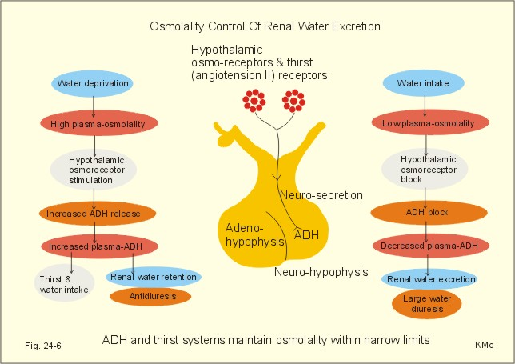

2. What are the causes of Syndrome of inappropriate antidiuretic hormone secretion (SIADH)?

Non-drug causes |  | Drug-induced
Pulmonary | Pneumonia  Tuberculosis  Abscess  Aspergillosis | Stimulate ADH | Antipsychotics  SSRIs  Tricyclics antidepressants  Carbamazepine  Vincristine  Ifosfamide  MDMA (ectasy)  Narcotics  Clofibrate  Chlorpropamide
Malignancy | Lung (especially small cell)  Gastrointestinal  Genitourinary  Lymphoma | Potentiate the action of ADH | NSAIDS  Cyclophosphamide  Chlorpropamide
CNS | Head injury  Intracerebral bleeds  Extra- and sub-dural bleeds  Tumours  Infections | ADH analogues | Desmopressin  Oxytocin  Vasopressin
Stress | Trauma  Surgery  Pain  Anaesthesia  (Appropriate response in field- but can be inappropriate and contribute to hyponatraemia particularly in patients receiving IV fluids)

Figure 2. (http://www.cvphysiology.com/Blood%20Pressure/BP015)

Renin/angiotensin/aldosterone system (RAAS)

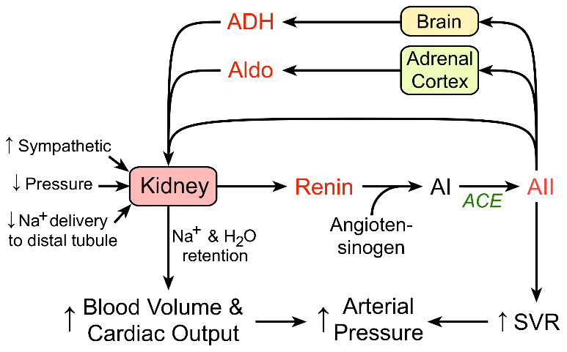

Related lecture/practicals/PBLs

- Block 2: Regulation of body water sodium and potassium
- Block 2: Regulation of blood pressure
- Block 2: Tubular reabsorption and secretion/excretion
- Block 2: Tubular reabsorption and secretion/excretion including some diuretics
- Block 2: Modulation of clearance by diuretics
- Block 2: Common complications in chronic kidney disease
- Block 3: Role of the adrenal gland – Lecture
- Block 3: Hormonal control of steroid and cellular metabolism – Lecture
- Block 3: Hypothalamo-pituitary axis – Lecture
- Block 3: Diabetes pathophysiology – Lecture
- Block 3: Thyroid function – Practical
- Block 3: Pituitary tumour – PBL
- Block 3: Negative feedback- Endocrinology – Practical
- Year 3: Endocrinology - FRS

References learning resources

[1] Ball SG, Iqbal Z (2016) Diagnosis and treatment of hyponatraemia. Best Pract Res Clin Endocrinol Metab 30: 161-173
[2] Williams DM, Gallagher M, Handley J, Stephens JW (2016) The clinical management of hyponatraemia. Postgrad Med J 92: 407-411
[3] Buffington MA, Abreo K (2016) Hyponatremia: A Review. Journal of Intensive Care Medicine 31: 223-236
[4] Cuesta M, Hannon MJ, Thompson CJ (2016) Diagnosis and treatment of hyponatraemia in neurosurgical patients. Endocrinologia y nutricion : organo de la Sociedad Espanola de Endocrinologia y Nutricion 63: 230-238
[5] Jimenez JV, Carrillo-Perez DL, Rosado-Canto R, et al. (2017) Electrolyte and Acid-Base Disturbances in End-Stage Liver Disease: A Physiopathological Approach. Digestive diseases and sciences 62: 1855-1871
[6] Liamis G, Filippatos TD, Liontos A, Elisaf MS (2017) Serum osmolal gap in clinical practice: usefulness and limitations. Postgraduate medicine 129: 456-459
[7] Negri AL, Ayus JC (2017) Hyponatremia and bone disease. Rev Endocr Metab Disord 18: 67-78
[8] Physiology of antidiuretic hormone
http://www.zuniv.net/physiology/book/images/24-6.jpg
[9] Renin/angiotensin/aldosterone system (RAAS) http://www.cvphysiology.com/Blood%20Pressure/BP015

