Do I look different or am I just ovary-acting?

Louise Goodall¹, David Handelsman,² Robert Schmidli ¹

¹ Department of Endocrinology, The Canberra Hospital, Canberra, Australia
² ANZAC Research Institute, Concord Repatriation General hospital, Concord, Australia

  - Case presentation:

A 56-year-old female was first referred to the department of Endocrinology for management of presumed steroid-induced diabetes. She had a background of end-stage renal failure secondary to reflux nephropathy and had undergone a renal transplant at the age of 17, followed by 2 further renal transplants at aged 20 and 53 after graft failure. Her medical history was also significant for transfusion-related hepatitis C with sustained virological response after definitive treatment, bilateral breast cancer with double mastectomy, previous cystic right ovary and parathyroidectomy with auto-transplantation in 1977. She went through menopause aged 50.

Her medications comprised of Levemir, NovoRapid, prednisolone 7.5 mg daily, tacrolimus 1mg BD, mycophenolate 720 mg BD, calcitriol 0.25 mcg BD, ranitidine 150 mg daily, and sodium bicarbonate 840 mg daily.

She complained of hair loss on her anterior head with minimal response to topical treatment. On examination, she had a coarse ‘weather-beaten’ appearance but was not obviously acromegalic. There was thinning on the anterior head but no male pattern baldness, fine downy hair on the face, sparse hair on the trunk and some acne over the back. Blood pressure was 120/70 mmHg and weight was 67.3 kg.

Biochemical hyperandrogenism was confirmed by a serum total testosterone in the adult male range at 14 nmol/L (reference range <3.2 mmol/L) with a sex hormone binding globulin of 52 nmol/L. LH and FSH were in the post-menopausal range at 69 U/L and 62 U/L respectively, and oestradiol was 104 pmol/L.

A trans-abdominal ultrasound showed a suspicious submucosal fibroid 12 x 6 x 6 mm but no adnexal mass, and an abdominal CT showed normal appearing adrenal glands.

She underwent ovarian vein sampling on two occasions, but the right ovarian vein could not be cannulated. There was a large left ovarian to peripheral gradient on both occasions.

She was commenced on GnRH antagonist Degarelix. This was accompanied by an injection site reaction after her second injection and severe hot flushes. Her testosterone was suppressed to <0.3 nmol/L after 2 weeks of treatment. There was also reduction in skin oiliness and acne but no change in facial hirsutism or glycaemic control. Intermittent Estalis continuous has been used to control hot flushes. The presence of gonadotrophin-dependent hyperandrogenism in the absence of an ovarian lesion is indicative of a diagnosis of ovarian hyperthecosis.

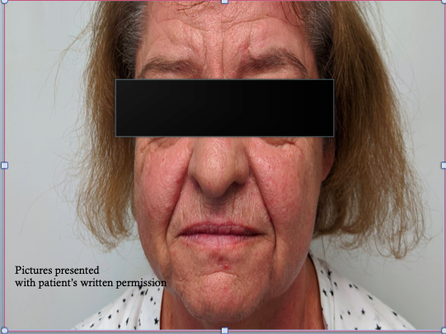
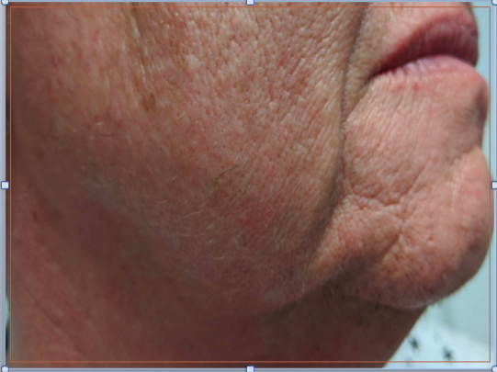
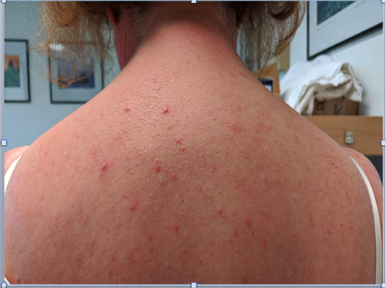

Figure 1: Physical appearance of the patient
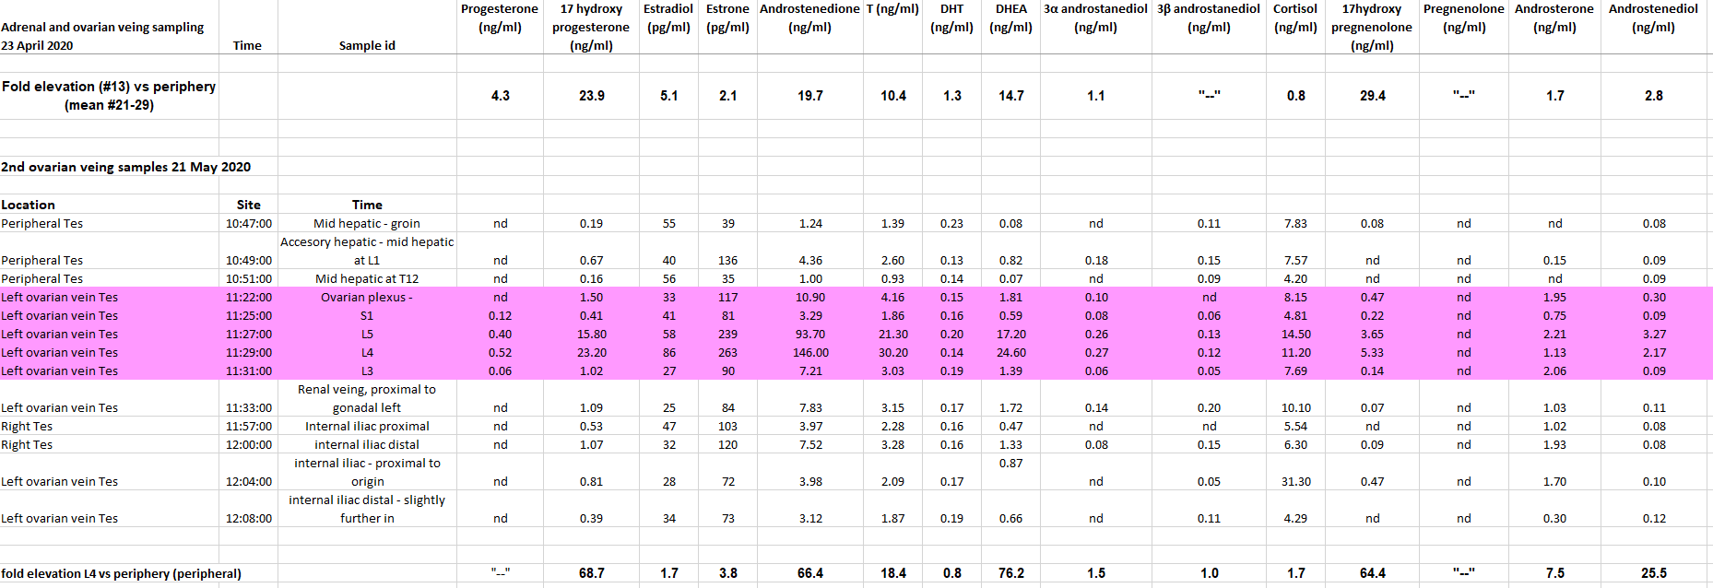

Figure 2: results from ovarian vein sampling

  - Discussion:

Although hyperandrogenism is relatively common, post-menopausal hyperandrogenism causing virilization is rare and warrants further investigation for potential neoplasia, especially if accompanied by erythrocytosis. Initial investigation should include imaging with either high-resolution cross-sectional imaging or pelvic ultrasound to identify malignancy. If this is not identified, further biochemical tests are warranted to differentiate between either ovarian or adrenal source of androgen production.

Adrenal sources of post-menopausal hyperandrogenism include adrenal tumours, adrenal Cushing’s syndrome and congenital adrenal hyperplasia. Androgen-secreting adrenocortical tumours can be identified with raised levels of adrenal androgens dehydroepiandrosterone (DHEA) or DHEA sulphate (DHEAS).

Adrenal Cushing’s syndrome can lead to increased serum testosterone due to glucocorticoid-induced stimulation of insulin-mediated ovarian testosterone secretion. However, as synthesis and secretion DHEA/S is regulated by pituitary ACTH, sustained suppression of central ACTH by adrenal Cushing’s syndrome leads to a reduction in DHEA/S. Another source of adrenal hyperandrogenism, late presentations of nonclassical congenital adrenal hyperplasia (NCCAH) could be identified by measurement of serum testosterone during low-dose dexamethasone suppression testing as serum testosterone production in this conduction is caused by ACTH as well as elevated serum 17-hydroxyprogestserone with ACTH stimulation.

As adrenal androgen secretion is not under the influence of LH, suppression of serum testosterone by at least 50% by long-acting GnRH analogue injection can reliably distinguish between ovarian and adrenal sources of androgen excess.

Causes of post-menopausal ovarian hyperandrogenism include virilising ovarian tumours (VOTs) and Ovarian hyperthecosis (OH). It can be difficult to differentiate between these two causes of virilization clinically or based on serum testosterone and gonadotropins alone. Small virilising tumours can be difficult to detect on imaging, Whilst adrenal androgen-secreting neoplasms are often discovered at a later stage with a higher incidence of malignancy, ovarian androgen-secreting neoplasms originating from Sertoli and Leydig cells tend to be well differentiated with more favorable outcomes.

OH is an uncommon cause of postmenopausal hyperandrogenism. Its occurrence is due to the differentiation of ovarian interstitial cells into steroidogenically active luteinized theca cells, which produce androgens independently of luteinizing hormone. It can be conceptualized as an extreme variant of polycystic ovarian syndrome (PCOS) in that its pathophysiology is that of insulin resistance and ovarian hyperandrogenism, however unlike PCOS where the luteinized thecal cells are confirmed to an area around cystic follicles, the nests of theca cells are scattered throughout the ovarian stroma. This is thought to present after menopause due to loss of granulosa cell mediated aromatization of testosterone to estradiol.

Although GnRH-analog suppression tests can differentiate between ovarian and adrenal sources of testosterone, they are unable to reliably distinguish between ovarian tumours and hyperthecosis.

As OH is associated with hyperinsulinism, serum testosterone may return to normal postmenopausal women with weight loss and metformin in patients with OH, however further studies are required to evaluate whether manipulating insulin resistance also improves testosterone levels in ovarian tumours.

Selective ovarian venous catheterization has been used to aid in the diagnosis and localisation of androgen secreting tumours, but studies have showed limited diagnostic accuracy. A case series of 136 women by Levens et al reported a diagnostic accuracy of only 66% of women with ovarian androgen-producing tumours.

Management of both OH and VOT is with either bilateral laparoscopic salpingo-oophrectomy in addition to lifestyle measures and insulin sensitization with metformin. However, suppression of gonadotropins with long-acting GnRH analogues is an alternative medical management strategy for both VOT and OH. Anti-androgen therapy with either cyproterone acetate or spironolactone can also be used to lower serum testosterone and improve the clinical symptoms of hyperandrogenism.

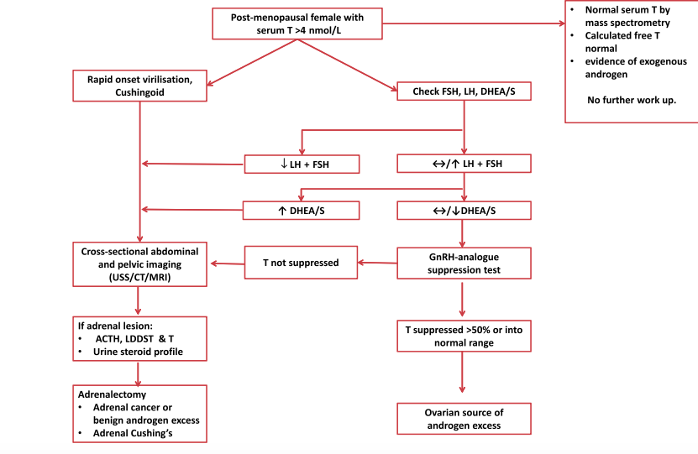

Mamooee et al ( vi)
Figure 3: algorithm for determining source of androgen excess

  - Take home messages:
- Hypererandrogenism in a post-menopausal female is rare and warrants investigation for benign and malignant adrenal and ovarian tumours, congenital adrenal hyperplasia and Cushing’s syndrome
- Ovarian hyperthecosis is due to the presence of nests of luteinized thecal cells in the ovarian stroma
- Management of ovarian causes of hyperandrogenism is to lower testosterone with bilateral salpingo-oophrectomy

Kozan P, Chalasani S, Handelsman DJ, et al. A Leydig cell tumour of the ovary resulting in extreme hyperandrogenism, erythrocycosis, and recurrent pulmonary embolism. J Clin Endocrinol Metab. 2014; 99: 12-17
Dennedy MC, Annamalai AK, Prankerd-Smith O, et al. Low DHEAS: A sensitive and specific test for the detection of subclinical hypercortisolism in adrenal incidentalomas. J Clin Endocrinol Metab 2016; 102: 786-792
Kaltsas GA, Isidori AM, Kola BP, et al. The value of the low-dose dexamethasone suppression test in the differential diagnosis of hyperandrogenism in women. J Clin Endocrinol Metab 2003; 88: 2634-2643
Marcondes JAM, Curi DDG, Mastsuzaki CN, et al. Ovarian hyperthecosis in the context of an adrenal incidentaloma in a postmenopausal woman. Arq Bras Endocrinol Metabol. 2008; 52: 1184-1188.
Fanta M, Fischerova D, Indrielle-Kelly T, et al. Diagnostic pitfalls in ovarian androgen-secreting (Leydig cell) tumours: case series. J Obstet Gynaecol 2019; 39(3): 359-364.
Mamoojee Y, Ganguri M, Taylor N, et al. Clinical case seminar; Postemenopausal androgen excess- challenges in diagnostic work-up and management of ovarian hyperthecosis. Clin Endocrinol (Oxf) 2018; 88(1): 13
Levens ED, Whitcomb BW, Csokmay JM, et al. Selective venous sampling for androgen producing ovarian pathology. Clin Endocrinol (Oxf) 2019; 70(4): 606-614
Vollard ES, van Beek AP, Verburg FA, et al. Gonadotropin-releasing hormone agonist treatment in postmenopausal women with hyperandrogenism of ovarian origin. J Clin Endocrinol Metab 2011; 96: 1197

