Pt UR 2031 3013
HYPONATRAEMIA CPC

Ferdinand Tobruk is a 34-year-old fund manager who present to the emergency department on a Sunday morning complaining of increasing lethargy, confusion and nausea over the past three weeks. He has also suffered from periodic headaches in the same time period. His concerned girlfriend had encouraged him to seek medical assistance as he was feeling so awful on the weekend and appeared confused. He attends the Emergency Department.

- You are the intern seeing Ferdinand for the first time. Please comment on the pertinent findings in Ferdinand’s UECs.

Na 117mmol/l [135-145]
K 3.7mmol/l [3.5-5.2]
Cl 87mmol/l [95-110]
Urea 3.0mmol/l [2.5-7.5]

Cr 55µmol/l [60-110]
Bicarbonate 17mmol/l [22-32]
Glucose 3.5mmol/l [3.5-5.5 fasting]

Ferdinand’s serum UEC show very marked hyponatraemia with accompanying low chloride, creatinine, bicarbonate and borderline low glucose

- How are the levels of serum sodium normally controlled in the human body?

Sodium balance in the human body is a complex interplay between sodium intake/excretion, water intake/excretion (thirst), sensing of serum osmolality by hypothalamic osmoreceptors and the macula densa of the kidney and control of water and salt balance via the Renin-Angiotensin system (RAS), antidiuretic hormone secretion from the posterior pituitary and other hormones such as the natriuretic peptides.

The human hypothalamus possesses osmoreceptors that sense serum osmolality. Osmolality is mainly determined by the serum concentrations of solutes such as sodium, chloride, potassium, bicarbonate, proteins, glucose and also foreign solutes e.g. drugs. Serum sodium is the most abundant cation in human extracellular fluids and thus is the main contributor to serum osmolality.

Increased osmolality as would be seen in hypernatraemia, causes an increase in the central drive for thirst/water intake as well as inciting the posterior pituitary supraoptic and paraventricular nuclei to secrete vasopressin (antidiuretic hormone/ADH) which acts on the kidneys to decrease water excretion via several mechanisms. Reduced blood volume is a less potent stimulus for ADH secretion.
ADH also causes peripheral vasoconstriction.

The kidney pays a role in sensing plasma osmolality via sensing of NaCl delivery to the nephron by the macula densa of the distal convoluted tubule. Cells of the macula densa sense both low Na/Cl delivery (e.g. hyponatraemia) as well as low renal blood flow causing the juxtaglomerular cells of the afferent arteriole to secrete renin. Via the RAS system, renin results in an increase in angiotensin II which serves to increase vasoconstriction, increase aldosterone secretion from the adrenal cortex causing renal Na retention/resorption, and increased ADH secretion. This serves to increase water and salt retention thus increasing circulating blood volume.

The natriuretic peptides e.g. Atrial Natriuretic Peptide (ANP) contribute to serum sodium homeostasis by increasing sodium and water excretion in the kidney in response to atrial dilatation due to increased blood volume as well as hypernatraemia and angiotensin II.

Decreased osmolality as would be seen in hyponatraemia causes the opposite effects to those described above.

Serum sodium levels play important roles in regulation of blood volume and pressure, pH, osmolality, concentrations of other serum electrolytes and cell function (particularly neurons and muscle including cardiac muscle).

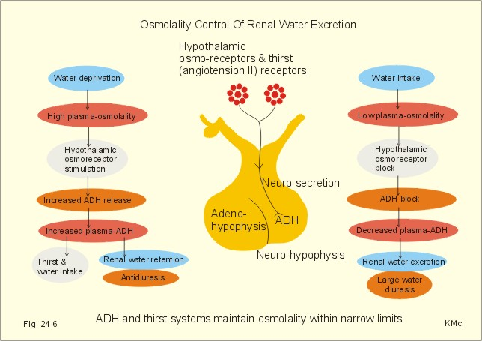

http://www.zuniv.net/physiology/book/images/24-6.jpg

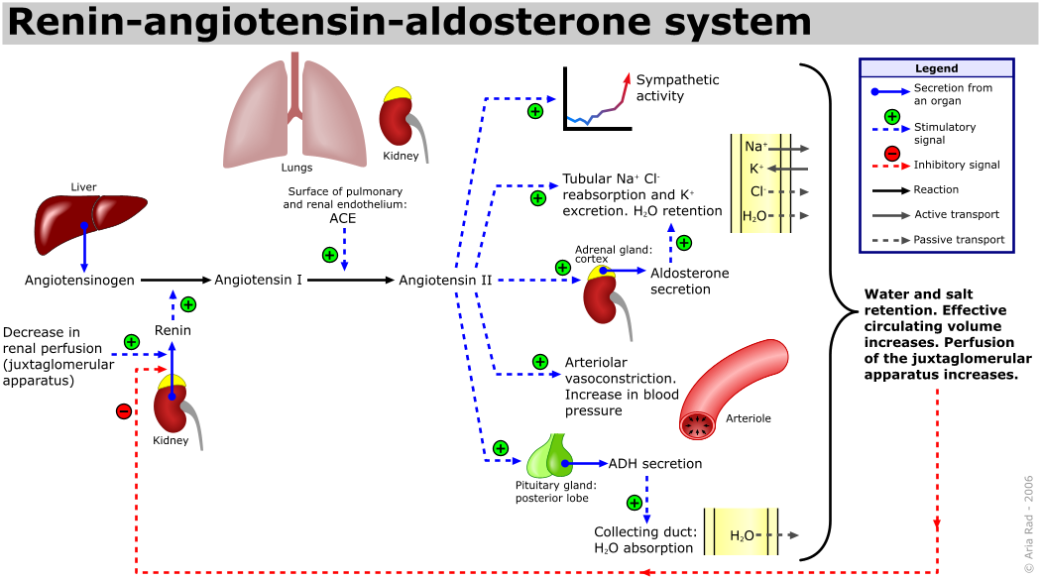

By A. Rad (me) - Own work, CC BY-SA 3.0, https://commons.wikimedia.org/w/index.php?curid=549506

- How are the possible causes of hyponatraemia commonly classified? Note down the common causes within each category.

Hyponatraemia may be viewed as a condition of imbalance of water homeostasis that affects the concentration of serum sodium. For this reason, hyponatraemia is
traditionally classified according to the patient’s blood volume status which may be hypovolaemic (decreased total body water and total body sodium), euvolaemic (increased total body water but no oedema, total body sodium increased or decreased) or hypervolaemic (increased total body water and total body sodium).

The majority of the causes of hyponatraemia relate to either disorders of ADH secretion or renal sensitivity to ADH, or water intake. It should be noted that blood volume (not just osmolality) is another key determinant of ADH secretion. ADH secretion may be appropriate (physiologically beneficial) or inappropriate.

It should also be noted that the serum sodium concentration in isolation does not allow determination of either the total body water (volume status) or total body sodium, as it is just a measure of the ratio of sodium to water. Assessment of volume status combined with measure of urinary sodium concentrations/ and osmolality assist differentiation of the various causes.

Osmolality of the blood is not only determined by sodium, but also by the presence of other solutes such as glucose. Presence of these excess serum solutes e.g. hyperlipidaemia, paraproteinaemia can cause the sodium concentration to be measured as falsely low (pseudohyponatraemia) due to the excessive contribution of alternative solutes to the volume of plasma (usually assumes plasma is composed of 93% water).

Causes of Hyponatraemia
 | Hypovolaemia | Euvolaemia | Hypervolaemia
Pathophysiology | ↓ blood volume ↑ ADH  H₂O retention & ↑ thirst | ↑ total body water without oedema | ↑ total body sodium, with greater increase in total body water. Oedema present
Causes | Extrarenal NaCl & H₂O loss without adequate oral replacement  e.g. GIT loss, diarrhoea, vomiting, sweating, burns, third-spacing (urinary Na⁺ low)  Renal Na⁺ wasting e.g. hypoaldosteronism, salt-losing nephropathies or impaired renal tubular function, thiazides, bicarbonaturia, osmotic diuresis e.g. glycosuria.  (urinary Na⁺ high)  Cerebral salt wasting | SIADH (syndrome of inappropriate antidiuresis): diverse causes  Adrenocortical failure (glucocorticoids usually exert negative feedback on ADH release)  Hypothyroidism | Low effective circulating blood volume/pressure ↑ ADH e.g. Congestive heart failure, cirrhosis, nephrotic syndrome (urinary sodium low)
Low urinary osmolality:
- Low solute intake e.g. alcoholism (beer is low in sodium), unusual or extreme diets low in sodium
- Excessive free water intake exceeding the capability of the kidneys to clear the free water

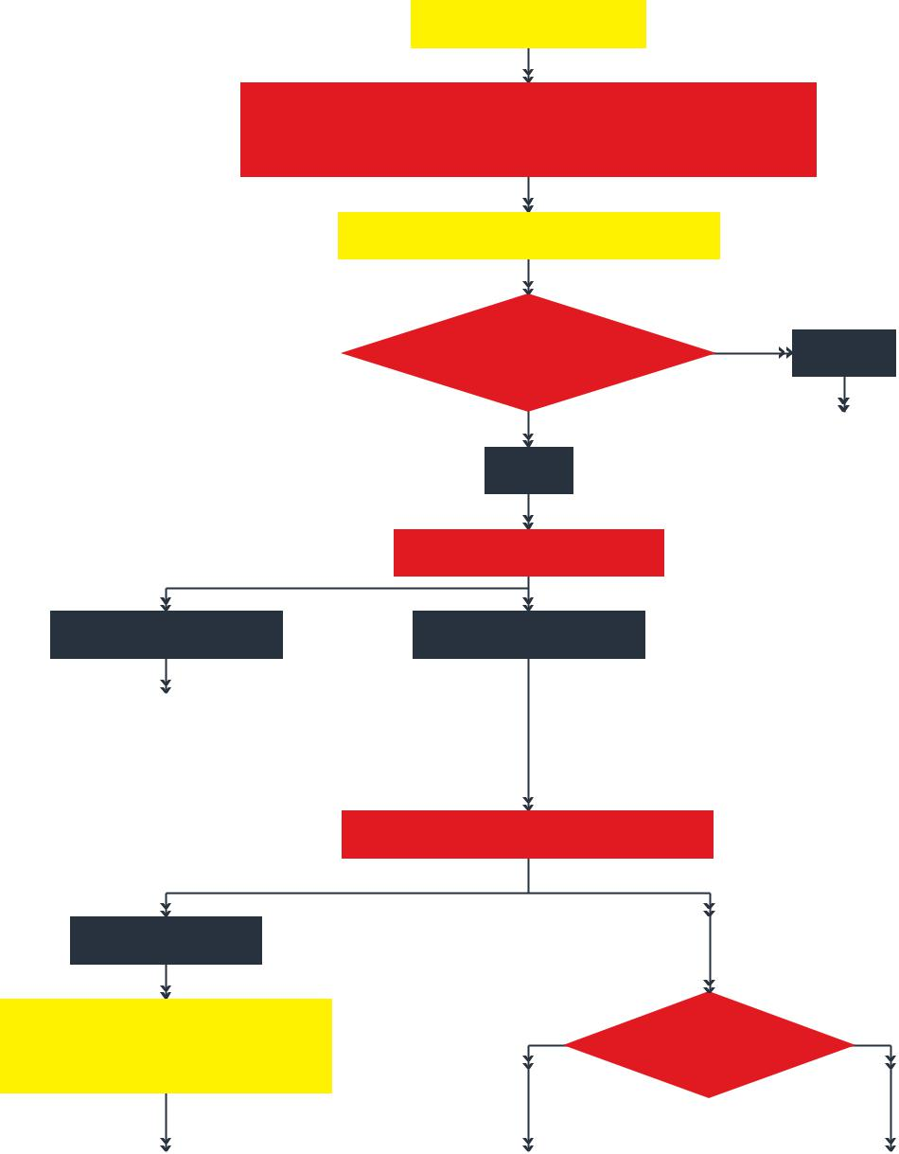

Hyponatraemia

Exclude hyperglycaemia and other causes of non-hypotonic hyponatraemia

≤ 100 mOsm/kg

Consider

- Primary polydipsia

- Low solute intake

- Beer potomania

≤ 30 mmol/l

Low effective arterial blood volume

If ECF expanded consider

- Heart failure

- Liver cirrhosis

- Nephrotic syndrome

If ECF reduced consider

- Diarrhea and vomiting

- Third spacing

- Remote diuretics

Hypotonic hyponatraemia

Acute or severe
Yes
symptoms?

Consider immediate treatment
_{No} with hypertonic saline

Urine osmolality

> 100 mOsm/kg

Urine sodium concentration

 |  |  |  | > 30 mmol/l
 |  |  |  | Diuretics or
 |  |  |  | kidney disease?
 | Yes |  |  |  |  |  | No
Consider |  |  |  |  | If ECF reduced consider
- Diuretics |  |  |  |  | - Vomiting
- Kidney disease |  |  |  |  | - Primary adrenal insufficiency
- All other causes |  |  |  |  | - Renal salt wasting
 |  |  |  |  | - Cerebral salt wasting
 |  |  |  |  | - Occult diuretics
 |  |  |  |  | If ECF normal consider
 |  |  |  |  | - SIADH
 |  |  |  |  | - Secondary adrenal insufficiency
 |  |  |  |  | - (Hypothyroidism)
 |  |  |  |  | - Occult diuretics

- What is SIADH?

SIADH (Syndrome of Inappropriate Antidiuresis) is a condition in which there is inappropriate secretion of ADH or increased sensitivity to ADH.
This is usually combined with an increased free water intake due to the fact that the threshold osmolality to incite thirst is lowered. The major causes are extremely diverse and entail drugs, disorders of the central nervous system, lung diseases, and paraneoplastic ADH secretion (various malignant neoplasms especially small cell lung carcinoma).

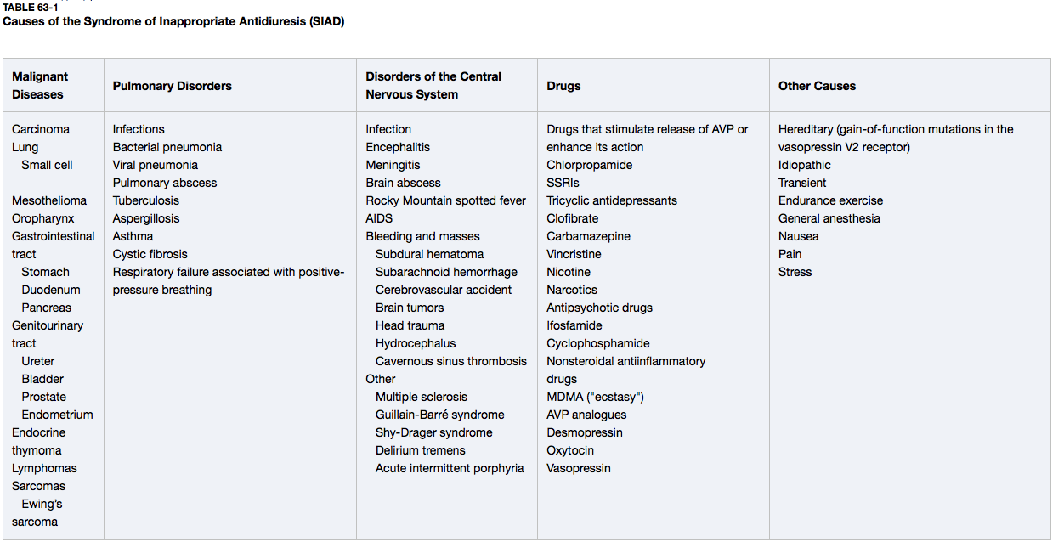

- What important questions would you ask Ferdinand when you take his medical history and why?

Presenting complaint:
Headaches and confusion warrant extensive neurologic history, including red flags of headaches, and visual/neurologic deficits, symptoms of high intracranial pressure. Given his confusion, assistance with the history by asking his next of kin may be necessary.

Nausea has diverse causes including gastrointestinal, central, toxic/drug, metabolic/endocrine, infectious and psychogenic causes.

Given his hyponatraemia, some assessment/quantification of volume status (oedema, thirst, water and salt intake), and fluid losses is necessary (vomiting, diarrhoea, sweating, diuresis).

Hyponatraemia also warrants a thorough endocrine history to exclude pituitary, thyroid and adrenal endocrine causes.

* NOTE* The time course of his symptoms is also important as an acute onset of hyponatraemia is a medical emergency. Patients may cope better physiologically if the onset of the disorder is chronic and the risk of catastrophic sequelae is less.

PMHx:
Previous history of significant medical diseases including intracranial, lung, endocrine disorders, malignancy.

Medications and allergies (medications are a common cause of SIADH and nausea)

Social:
Smoking history (risk of malignancy)
Recreational drugs (may cause SIADH e.g. ecstasy)
Diet (watch out for unusual or extreme diets and extreme exercise e.g. extreme restriction diets, excessive water intake, extreme exercise with sweating losses)
alcohol intake (alcoholism with exclusive intake of low solute fluids such as beer can cause hyponatraemia e.g. beer potomania)

Family History
Malignancy, endocrine disorders

Systems review (to assess for symptoms of malignancy, endocrine disorder such as adrenocortical failure, hypothyroidism, diabetes, intracranial or pulmonary diseases that could cause SIADH, significant liver or cardiac disease that could cause neurohumoral RAS activation)

Further history reveals that Ferdinand has
been a smoker of one pack of cigarettes per day since he was 18.
He drinks seven standard drinks per week and does not have any allergies. He has a family history of colorectal carcinoma (mother, aged 47) and autoimmune thyroid disease (mother and sister).

- What findings would you assess for on a physical examination of Ferdinand?

General observation: look for stigmata of endocrine disease (pigmentation, Cushing’s acromegaly, hypothyroidism etc.), oedema
Vital signs: assists with determination of volume status of patient. This includes looking for oedema, JVP
The specific examination is broad and includes thorough endocrine, pulmonary, cardiovascular and neurologic examinations.

On examination of Ferdinand you notice that he is alert and comfortable. He is oriented in place and day of week but not day of month. Blood pressure 109/70 lying, 92/60 standing. Jugular venous pressure is normal and there is no peripheral oedema. There is no gynaecomastia, he has a normal male hair distribution and testicular volume is 12ml bilaterally. There is no visual field defect to confrontation. There are no cardiac murmurs and lung fields are clear. Abdominal examination is normal.

- What investigations would you order and why?

Serum UEC: determine renal function, severity of hyponatraemia, other electrolyte disturbances (hyperkalaemia may suggest adrenal insufficiency), serum uric acid (may be reduced in SIADH and other salt wasting syndromes, but raised in hypovolemic states)

Serum osmolality: severity of osmolar derangement, determination of pseudo versus true hyponatraemia, hypertonic/normotonic or hypertonic hyponatraemia causes

Urine osmolality: differentiates between conditions with impaired free water excretion by kidney (e.g. SIADH); may be appropriate or inappropriate given clinical situation. In particular, a high urine osmolality suggests excess ADH whereas low urine osmolality suggests increased free water intake.

Urinary sodium: differentiates between SIADH (high urinary sodium if salt intake retained) and hypovolaemic hyponatraemia (low urinary sodium).

Others, underlying cause
Serum albumin: nephrotic syndrome, cirrhosis
Serum glucose: pseudohyponatraemia.
Cortisol, ACTH or Short synacthen test: exclude adrenocortical failure
TSH, FT4: exclude primary/secondary hypothyroidism

Serum fasting lipids: exclude pseudohyponatraemia
Serum and urine protein electrophoresis: exclude pseudohyponatraemia

Plain Chest X-ray/CT: lung masses, other pulmonary disease associated with SIADH
Head CT or MRI: exclude intracranial pathology (cerebral salt wasting)

Further tests:

uNa 154mmol/l
uOsmolality 713mmol/kg

Cortisol 186nmol/l [100-540]
FT4 5.6pmol/l [10.7-17.0]
TSH 1.20mIU/L [0.34-3.4]
LH 0.6U/L [<12]
FSH 2.7U/L [<12]
Testosterone 0.9nmol/l [7.0-31.0]
IGF-1 <2.0nmol/l [8-42]
Prolactin 255mIU/L [<450]

Chest X-ray
“The mediastinal and cardiac silhouettes are within normal limits. The lungs and pleural spaces are clear. There is no free air.”

MRI brain & pituitary fossa
The sella is expanded and contains a large mass with suprasellar extension.
The mass measures approximately 36 x 41 x 41 mm in diameter and has a
'snowman' appearance on the coronal images due to indentation at the
diaphragma sellae.
The mass is heterogenous on the T2-weighted sequence with areas of
hypointensity and slight hyperintensity when compared with the adjacent grey
matter. The mass is relatively homogenous in intensity on the T1 weighted
sequence and is predominantly isointense to the adjacent grey matter.
Moderate, inhomogenous enhancement is demonstrated on the postcontrast image.
Superiorly, the mass displaces the circle of Willis. Its immediate branches
demonstrate normal flow voids. There is also superior displacement of the optic chiasm with compression of the chiasm the superior margin of the mass and inferior frontal lobes, worse
on the right.
On the left the tumour extends lateral to the intracranial line with loss of cavernous sinus enhancement medial to the carotid
Impression:
Appearances are in keeping with a large pituitary macroadenoma with suprasellar extension. There is compression of the optic chiasm, worse on the right with likely invasion of the left cavernous sinus

- What are the possible adverse consequences of hyponatraemia? How does the time course of the condition affect the risk of adverse sequelae?

Due to low extracellular osmolality in hyponatraemia, water moves along the osmotic gradient into cells leading to cell swelling.

Neuronal swelling is responsible for many of the adverse clinical manifestations of hyponatraemia, namely acute hyponatraemic encephalopathy. The CNS tries to combat neuronal swelling by shunting fluid from the interstitial space into the CSF. If this mechanism is overwhelmed then cerebral oedema results with the encephalopathic complications ranging from mild (nausea, headache, vomiting) to severe (confusion, seizures, herniation, coma, death). Premenopausal women, and those with an acute (less than 48 hours) onset of hyponatraemia appear to be most at risk of this condition.

If the time course of onset of hyponatraemia is more chronic then the brain may adapt to the changes by causing organic intracellular solutes such as creatinine and glutamate to exit cells, thus reducing water entry into cells along the osmotic gradient. This process happens fairly rapidly (over 48 hours) which is why this is the determinant of acute versus chronic hyponatraemia. Patients with an acute time course of disease are still at risk of neurologic sequelae, but usually at more marked depressions of serum sodium.

Chronic hyponatraemia is associated with a decrease in bone density.

- Outline your initial approach to the management of Ferdinand’s severe hyponatraemia. Why is the speed of correction of his hyponatraemia important?

IV access.
Correct Cortisol deficiency
IV Hydrocortisone 100mg
Follow with 50mg qid, taper according to clinical state
Correct hypothyroidism (NB must treat cortisol deficiency first to avoid crisis)

General treatment of hyponatraemia
Treat underlying cause eg:
Stop offending drugs (eg. thiazides, fluoxetine)
Infection
Hypovolaemia
Hyponatraemia with severe symptoms:
Assess severity clinically. Do not use sodium concentration
Monitor in ICU if possible
150ml IV 3% hypertonic saline over 20min
Re-check sodium 20min later, while repeating 150ml 3% saline
Repeat until 5mmol/l increase in sodium concentration
Limit rise in sodium concentration to 10mmol/l first 24h then 8mmol/l during every subsequent 24h, until sodium concentration ≥ 130mmol/l
Follow-up: monitor sodium concentration after 6 and 12h, then daily
Hyponatraemia with moderately severe symptoms:
Risks of rapid correction with hypertonic saline may outweigh benefits
Monitor clinically, hypertonic saline if condition deteriorates
Begin by attempting to treat underlying cause, if present
Hyponatraemia with mild symptoms:
Treat underlying cause
Fluid restriction approx. 1L/day
Second-line treatments
Oral sodium chloride
Loop diuretics
Oral urea
Avoid (may be harmful, little evidence for benefit)
Lithium
Demeclocycline
Vasopressin receptor antagonists

Osmotic demyelination

The speed of correction of hyponatraemia should be slow (no more than 10 per 24 hour), in patients with chronic hyponatraemia. Patients are at risk of osmotic demyelination syndromes, most commonly in the pons (Central Pontine Myelinolysis, CPM). CPM is a catastrophic condition that may result in permanent quadriparesis, locked-in-syndrome, cranial nerve deficits or loss of consciousness and death. Extrapontine demyelination may also occur. This is due to the fact that organic solutes take a longer time to reaccumulate after serum sodium correction. Oligodendrocytes are most susceptible to osmotic injury, and combined with disruption of the blood-brain barrier, demyelination occurs. Additional risk factors include malnutrition, alcoholism, hypokalaemia, liver transplantation and overcorrection of hyponatraemia.

- Please interpret Ferdinand’s Head CT scan or MRI scan??

NEED PICTURE OF PATIENTS SCAN (CAN YOU GET THESE RADIOGRAPHS FOR ME WITH THE REPORTS? IT WOULD BE GOOD IF WE HAD THE SCAN OF THE PATIENT THAT YOU HAD IN MIND FOR THE CPC.

- What is the most likely diagnosis?

Ferdinand also has a pituitary macroadenoma with compressive symptoms, which is apparently non-functioning. Pituitary adenomas have been associated with hyponatraemia due to:
Suppression of ACTH and secondary adrenocortical failure
Suppression of TSH and secondary hypothyroidism
SIADH
Cerebral salt-wasting syndrome.

Hyponatraemia in adrenal insufficiency is due to an inappropriate increase in vasopressin secretion and action, and impaired ability to excrete free water. Cortisol deficiency increases hypothalamic Corticotrophin Releasing Hormone (CRH) secretion, which is an ADH secretagogue.

Cerebral salt wasting (CSW) is characterised by hyponatraemia and extracellular fluid depletion due to inappropriate urinary sodium loss. It occurs particularly in patients with subarachnoid haemorrhage and may follow neurosurgery. The existence of CSW is controversial, and it may simply represent combination of SIADH and unrecognised volume expansion. The cause is unclear but it may involve the sympathetic nervous system or natriuretic peptides.

Ferdinand was treated at presentation with oral glucose gel and IV hydrocortisone. He was changed to a tapering dose of oral hydrocortisone and thyroxine was started. His sodium level came up to 122mmol/l within one day and was 133 three days after admission. He underwent transsphenoidal resection of his pituitary lesion which is confirmed to be a benign pituitary adenoma.

Patient didn’t have field defects in real life. Suggest adding picture of bitemporal defect her and normal fields.

